**TI India**

*Analog Design Contest 2011*

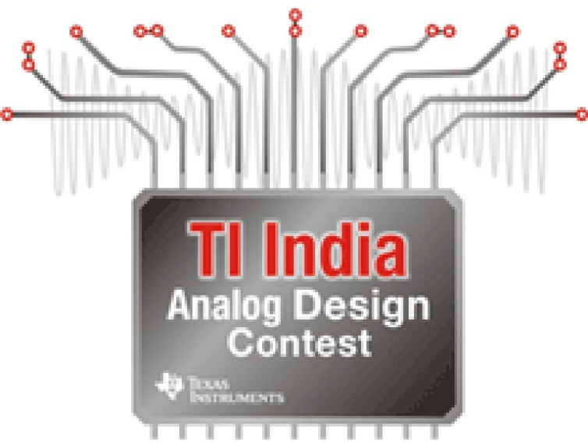

**SMART LIBRARY**

**MANAGEMENT SYSTEM**

**AMIT RANJAN**

**DEEPENDER SINGLA**

**GURSIMRAN SINGH**

**Mentor: Mr. M.D Singh**



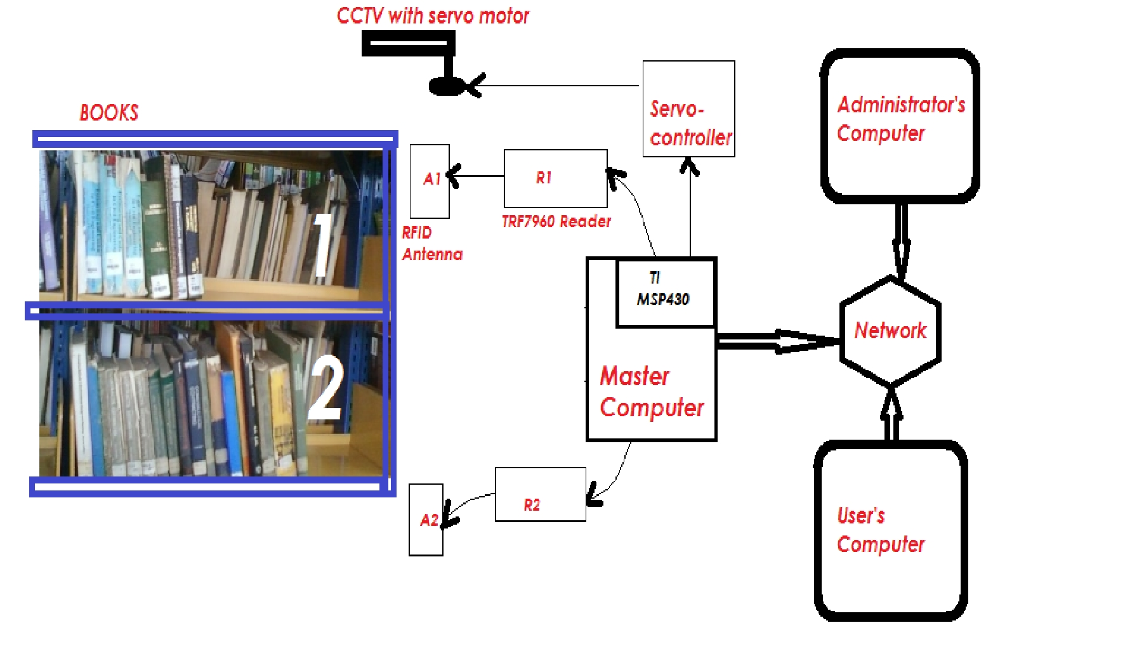

|  |  |  |  |
| --- | --- | --- | --- |
| Technology  Capability | Bar Code | Present RFID | Our System |
| Line of Sight Requirement | **Required** | **Not Required** | **Not Required** |
| Book Theft | **Possible** | **Possible** | **Theft Free** |
| Tampering of book | **Possible** | **Possible** | **Condition improved** |
| Real time updating of book | **Not Possible** | **Not Possible** | **Possible** |
| Unauthorized use of card | **Possible** | **Possible** | **Condition Improved** |
| Book Issue/ return on-the-fly | **Not Possible** | **Not Possible** | **Possible** |
| Reviews of Books | **Not Possible** | **Not Possible** | **Possible** |

Fig- Block diagram of set-up

**Comparison**